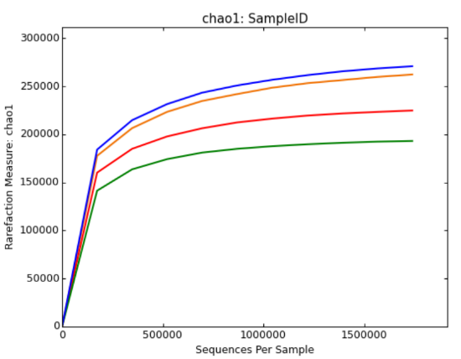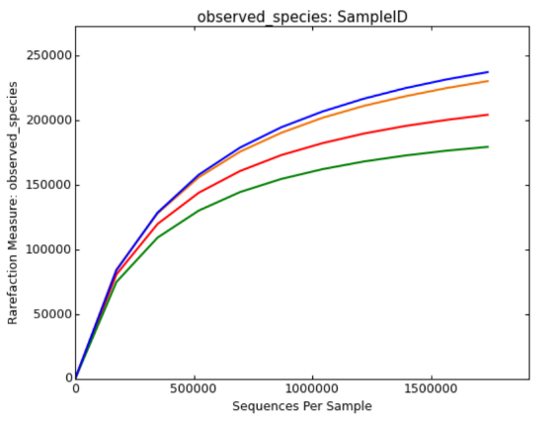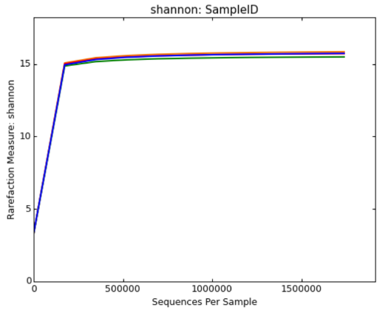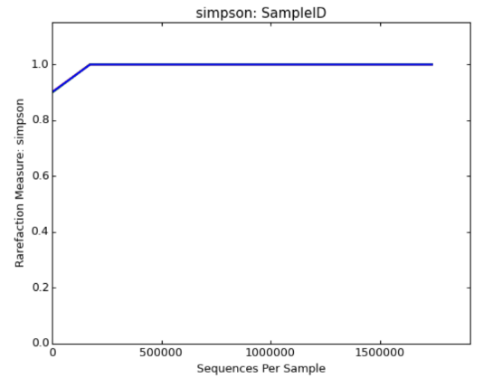
Fig .S1 Rarefaction analysis for four communities.

Fig. S2 Phylogenetic analysis based on the partial amino acid sequences of GH1B β-glucosidase genes selected from representative sequences used to design qPCR primers and their relationship with the reference sequences retrieved from Genbank. The tree was constructed using the neighbor-joining method.

